


Informatics Institute of Technology
School of Computing
Software Development II Coursework Report

Module : 4COSC010C.2: Software Development II (2023)
Date of submission :
Student ID : 20222350/ W2053156
Student First Name : Nainar Ali
Student Surname : Ahamed Aathif
Tutorial group (day, time, and tutor/s):

"I confirm that I understand what plagiarism / collusion / contract cheating is and have read and understood the section on Assessment Offences in the Essential Information for Students. The work that I have submitted is entirely my own. Any work from other authors is duly referenced and acknowledged."

Name : Ahamed Aathif
Student ID : 20222350

Self-assessment form and test plan

Self-assessment form
Task | Self-assessment (select one) | Comments
1 | ☒Fully implemented  ☐Partially implemented  ☐Not attempted
2 | ☒Fully implemented  ☐Partially implemented  ☐Not attempted
Insert here a screenshot of your welcome message and menu:

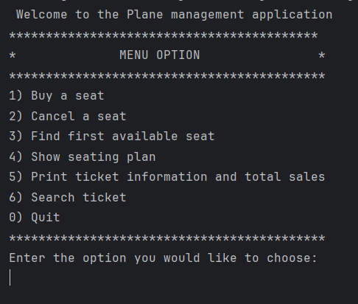

3 | ☒Fully implemented  ☐Partially implemented  ☐Not attempted
4 | ☒Fully implemented  ☐Partially implemented  ☐Not attempted
5 | ☒Fully implemented  ☐Partially implemented  ☐Not attempted
6 | ☒Fully implemented  ☐Partially implemented  ☐Not attempted
Insert here a screenshot of the seating plan:

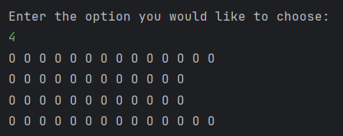

7 | ☒Fully implemented  ☐Partially implemented  ☐Not attempted
8 | ☒Fully implemented  ☐Partially implemented  ☐Not attempted
9 | ☒Fully implemented  ☐Partially implemented  ☐Not attempted
10 | ☒Fully implemented  ☐Partially implemented  ☐Not attempted
11 | ☒Fully implemented  ☐Partially implemented  ☐Not attempted
12 | ☒Fully implemented  ☐Partially implemented  ☐Not attempted

Test Plan
Complete the test plan describing which testing you have performed on your program.
Add as many rows as you need.

Part A Testing
Test case / scenario | Input | Expected Output | Output | Pass/Fail
Buy a seat | Valid row letter and seat number | Confirmation message for successful sale of seat | As expected | ☒Pass  ☐Fail
Cancel a seat | Valid row letter and seat number of sold seat | Confirmation message for cancellation of seat | As expected | ☒Pass  ☐Fail
Find first available | Choose option 3 from menu | Display first available seat (row, seat number) | As expected | ☒Pass  ☐Fail
Show seating plan | Choose option 4 from menu | Display current seating plan with seat status | As expected | ☒Pass  ☐Fail
Quitting the Program | Choose option 0 from menu | Program exits without any errors | As expected | ☒Pass  ☐Fail
☐Pass
☐Fail
☐Pass
☐Fail

Part B testing
Test case / scenario | Input | Expected Output | Output | Pass/Fail
Printing Tickets Info | Choose option 5 from menu | Displays ticket info and total sales amount | As expected | ☒Pass  ☐Fail
Searching for a Ticket | Choose option 6 from menu, provide valid seat and row | Displays ticket info or availability message | As expected | ☒Pass  ☐Fail
Saving Person Details | Valid row letter, seat number and person info | Confirmation message for successful sale of seat | As expected | ☒Pass  ☐Fail
☐Pass
☐Fail
☐Pass
☐Fail
☐Pass
☐Fail
☐Pass
☐Fail

Are there any specific parts of the coursework which you would like to get feedback?
You will need to demonstrate your understanding of the submitted code. Your tutor will arrange a coursework demonstration. During the coursework demonstration, your tutor will ask you to execute your program and questions on your code.
Failure to attend the demonstration will result in 0 for the coursework.

- Code :
<<paste your code>>
<<Note : Do not use screenshots or images for the report.>>
<<Code should be pasted as text>>

<<END>>

